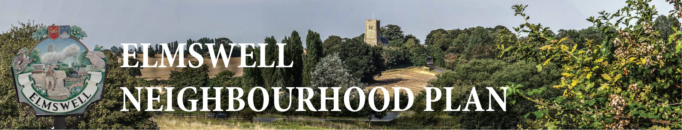

MINUTES OF A STEERING GROUP MEETING
held on 17th March 2015
at The Blackbourne
Present: Marian Abbott, Peter Dow, Peter Edmonds, Mary Feeney, Terry Garner,
Sarah Mansel (Ch.), Fred Pallett, Shaun Pratt, Ann Richards.
1 Apologies were noted from Philip Blisset, Julie Cole, & Peter Goodridge
2 The Minutes of the last meeting, held on 17th February, were accepted as a true
record.
3 There were no matters arising from the Minutes and not dealt with as an Agenda item.
4 Consultations by Sarah with the Police, by Terry & Marian with the Over 55’s Group and by Terry with the Cricket Club were noted, results to be fed into the subsequent discussion.
5 The latest draft of all 3 questionnaires, together with the header sheet, were considered
line-by-line and Peter D undertook to incorporate additions, deletions and changes into a
final version in each case.
5.1 Marian is to check with the Co-op, & Peter D with the Mace Stores, re their acting as collection points for paper returns.
5.2 Shaun is to provide plastic boxes to receive the completed questionnaires.
5.3 Peter D is to have Correx signs made advertising the need for people to fill in and
return the questionnaires
5.4 Peter D is to co-ordinate the inputting of data from hard copy returns by Group
members on a rolling programme basis to avoid a build-up
6 Peter D agreed to have the Youth Questionnaire finished and 70 copies ready for Marian &
Julie to take to Elmswell School on Friday 20th.
6.1 Peter D to continue to liaise with Thurston School towards their copies being with
them for the beginning of next term, 13th April.
7 Peter D & Sarah reported that both the 9th March ‘Neighbourhood Planning Masterclass’
run by Locality, Planning Aid England & the Planning Advisory Service at BSE and the
recent MSDC Neighbourhood Plan network meeting had been productive with further
insights into both the ‘base line statistics’ element and the process overall.
8 It was agreed that the base line statistics stage ought to be largely guided by professional
input. Peter D undertook to contact Rachel Hogger, a Planning professional and
Neighbourhood Plan specialist, as she had impressed at the Masterclass and had, when
approached, expressed an interest in taking on Elmswell’s Plan in this regard.
8.1 Peter D undertook to apply for further funding towards professional help.
...over...
9 The following timetable was agreed:
Distribute Household Questionnaires via Newsletter (Peter D to arrange) Friday 03.04
Deadline for returns to be Monday 20.04
Saturday morning sessions at the Co-op encouraging returns 11.04 & 18.04, Marian to
co-ordinate volunteers to attend.
9 The date of the next meeting to be fixed as either 15.04 or 16.04, Peter D to try so secure
attendance of Rachel Hogger on either date.
10 The meeting closed at 9.45.
Peter Dow
18.0315

